Credit Task 5.2 report

|  |  |
| --- | --- |
| Student Name | Lim Jia Lok |
| Student ID | 101212631 |

## SUB Task 5.2.1

#### Solution

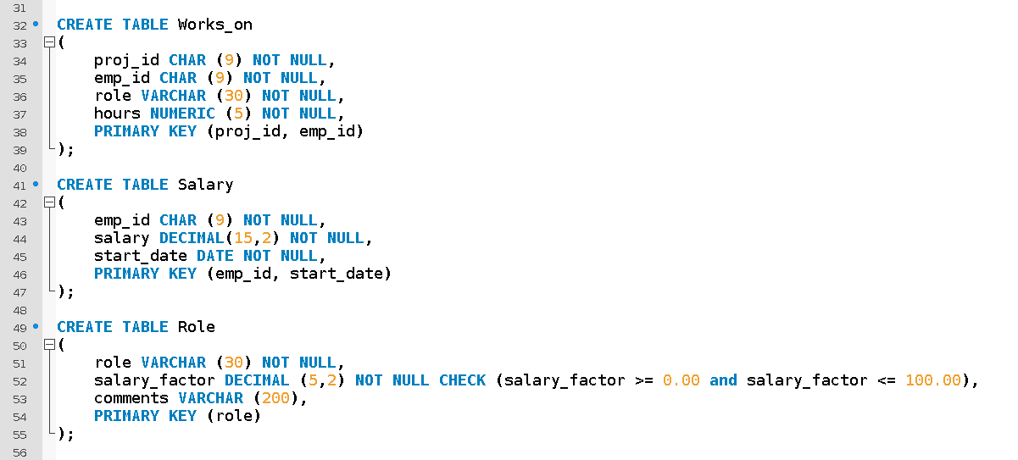

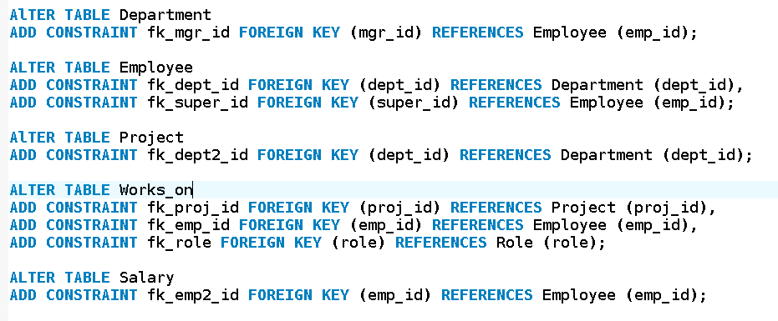

#### Comments/findings

The nullable attribute is comments. This is because the employee may or may not have comments about them. A new table is made which is role. This is to remove the transitive dependencies in the Works_on table.

(Where applicable)